Utopia business proposal

E-DUCATION_PWD: ONLINE SCHOOL FOR PEOPLE WITH DISABILITIES

#### PREPARED FOR

Anna Parker

Director of Student Entrepreneurs

Government of Utopia

Toronno, Utopia

#### prepared by

Jesus Jr. ANCHETA

Seneca College of Applied Arts and Technology

Seneca@York Campus

Toronno, Utopia

November 28, 2016

Table of Contents

INTRODUCTION 3

Statement of Need 3

Research 3

Potential Solution 4

Information Sources 4

THE PROPOSED PLAN 5

Web application design and development 5

Schedule 6

Budget 6

STAFFING & QUALIFICATIONS 7

Jesus Jr ANCHETA, Mr. 7

REFERENCES 9

CONCLUDING COMMENTS 10

Scope of Services 10

Benefits 10

Supporting Documents 10

## INTRODUCTION

ByteNet Software Solutions Incorporated (ByteNet) is an emerging company in web applications development founded by a group of former college students from Toronto, Canada. We are a company with high passion in creating web applications that promotes learning and equal access to education. Most of our works were exceptionally endorsed by public school teachers in Toronto who used our web applications as supporting tools in educating their students. This proposal details our plan to create a web application (E-DUCATION_PWD) that will provide an easy access to high quality education for people with disabilities (PWD). ByteNet is looking forward the opportunity to help improve the lives of people with disabilities thru proper education.

### Statement of Need

Quality education that can be access easily by people with disabilities is usually constraint by several factors as stated below.

* Transport to/from schools’ premises is one of biggest problem for students with people with disabilities to access education. Some educational institutions offer support for transport services however, the cost for this special arrangement were extremely high that parents/students cannot afford.
* Discrimination and harassment by non-disabled students commonly occurs also when people with disabilities is in group with other non-disabled students resulting to non-concentration on their studies.
* Even with the approval of Accessibility for Ontarians with Disabilities Act or AOADA last June 13, 2005 aims to identify, prevent and remove barriers for people with disabilities, its implementation to most sectors was not highly effective most especially to public schools due to lack of funds from the government.

### Research

According to research, people with disabilities find many difficulties in accessing education that affects also their employability.

* Per study, people with disabilities who are currently in school or had recently been in school, almost all (98%) stated that their disability directly impacted their educational experience due to above problems.
* The lack of a high school diploma may represent more of a barrier among those with disabilities. Among people who had not completed high school, 33% of those with a moderate disability were employed, compared with 50% of those with a mild disability and 65% of those without a disability.
* Lynda.com is currently the leading online platform that provides online courses for students. However, their platform is not design to cater people with disabilities which has different needs and learning abilities.

### Potential Solution

ByteSoft conducted a thorough research on special requirements and needs for people with disabilities to attain a quality education at their convenience. The outcome of this research proposed below solution.

#### SOLUTION: e-ducation_pwd: Online school for people with disabilities

This proposed online school for PWD is a web application that will be accessible thru internet and can eliminate the need to travel to attend classes at school. Unlike the regular online school offered by colleges/universities, this platform will be managed by actual instructors that has specialization in teaching people with disabilities like abilities to communicate in sign language.

The main feature of this web application is a real-time video/audio conference between the instructor and students to deliver the classes which can be viewed simultaneously. Progress of students can be monitored also in their profiles in this web application including submission of their assignments. Students using this web app allow them to interact with other students that will help them improve their social skills. Another good feature of this web application is an online library that will help each student do their research related to their courses without the need to open another browser.

### Information Sources

Learning Disabilities Association of Ontario, *“Learning Disabilities Statistics*”, 2015,

http://www.ldao.ca/introduction-to-ldsadhd/articles/about-lds/learning-disabilities-statistics/. Accessed November 26, 2016.

*“Access to Education for Students with a Disability: Barriers and Difficulties”*, Australian Human Rights Commission, https://www.humanrights.gov.au/publications/access-education- students-disability-barriers-and-difficulties. Accessed November 26, 2016.

“*Persons with Disabilities and Employment”,* Statistics Canada, November 27, 2015,

http://www.statcan.gc.ca/pub/75-006-x/2014001/article/14115-eng.htm

Accessed November 26, 2016.

Lynda.com from LinkedIn, *“Lynda: About us”,* https://www.lynda.com/aboutus/.

Accessed November 26, 2016.

## THE PROPOSED PLAN

### Web application design and development

Design and development of a web-based software follows six-stage process as described below.

#### STAGE 1. PLANNING AND REQUIREMENTS GATHERING

It is performed by the project manager with inputs from potential clients gathered thru interviews and online surveys. The information gathered will be used to plan the technical approach to implement the project and to understand operational risks involved.

#### STAGE 2. defining the requirements

This stage defined clearly the exact requirements of the project and its limitation. This will be documented as project requirements and will be approved by the customer. This approved document will be used as a reference during the design and development stages.

#### STAGE 3. designing the project

Based on the approved project requirements in stage 2, technical analysts of the team will come out with a project design that clearly defines all architectural requirements (e.g. platform, OS, programming languages, UIs, APIs), budget and time constraints. This will be reviewed and approved by all important stakeholders before it will proceed to the development stage.

#### STAGE 4. DEVELOPING the project

Actual development of the project is done on this stage by project leader and programmers. They build the project based from the approved design and use the specified programming tools as indicated in the design as well. Programmers must follow the coding guidelines by the organization and build only as per the approved design.

#### STAGE 5. TESTING the project

This stage is testing the project for defects that has been reported, tracked, fixed and retested until it reaches the required quality standard defined in the requirements of the project.

#### STAGE 6. DEPLOYment and maintenance

The project is released to the customers and used in a real-world environment. Trainings are provided to customers by our technical coach in our team. Upgrades, maintenance and support is also provided on this stage.

### Schedule

The following schedule is only an estimate and can be adjusted to a fixed schedule of completion after project design has been approved. Estimated completion date is July 17, 2017 if project commence on December 1, 2016.

|  |  |  |  |
| --- | --- | --- | --- |
| **Stages** | **Tasks** | **Days Required** | **Completion Date** |
| 1 | Planning and requirements gathering | 30 | January 09, 2017 |
| 2 | Defining the requirements | 15 | January 30, 2017 |
| 3 | Designing the project | 35 | March 09, 2017 |
| 4 | Developing the project | 100 | June 12, 2017 |
| 5 | Testing the project | 15 | June 30, 2017 |
| 6 | Deploying the project | 15 | July 10, 2017 |

### Budget

Development and operational cost of this project from start to completion is estimated as **CAD180,000**. Breakdown of this total cost is defined on below table.

|  |  |  |
| --- | --- | --- |
| **Item** | **Description** | **Cost (CAD)** |
| 1 | Development cost (includes surveys, salaries for systems analysts, programmers and project lead) | 100,000.00 |
| 2 | Rental office cost (for 6 months) | 10,000.00 |
| 3 | Equipment cost (e.g. software tools, computers, i-cloud subscription) | 50,000.00 |
| 4 | Office supplies & utilities | 5,000.00 |
| 5 | 1-month maintenance and support after successful deployment | 5,000.00 |
|  | **Total** | **CAD 180,000.00** |

## STAFFING & QUALIFICATIONS

Jesus Jr Ancheta is a well-experience project manager for web application development for more than 5 years. He led major projects like the newly deployed web-based payroll system of Air Canada, online inventory system of Holt Renfrew and online booking system of Expedia.ca. He will lead the project from planning up to deployment.

### Jesus Jr ANCHETA, Mr.

**JESUS JR ANCHETA**

Toronto ON M6A 1W8 • (647) 778 7210 • [janchetajr@gmail.com](mailto:janchetajr@gmail.com)

<https://ca.linkedin.com/in/jancheta>

**OBJECTIVE**

To obtain a coop position in IT field where I can further develop my technical skills, and apply my logistical and administrative backgrounds to make positive contributions to your company.

**PROFILE**

* Strong analytical, and problem solving skills developed through more than 5 years experience as logistics coordinator
* Detailed-oriented, fast learner and well-organized individual
* Excellent interpersonal skills, and able to work independently and in a team environment
* Certified level 1 tutor by CRLA & consistent President’s Honor List
* Fluent in Filipino and Ilocano

**TECHNICAL SKILLS**

|  |  |
| --- | --- |
| Operating Systems | Windows OS, Windows Server 2012, Linux/UNIX, IBM iSeries |
| Programming Languages | C, C++, IBM RPG & CL, C#, Java, SQL |
| Web Technologies | HTML5, CSS, JavaScript, PHP, ASP.NET |
| Databases | DB2, MYSQL, Oracle |
| Tools | MS Office Suite, Visual Studio 2013/2015, Brackets, Sublime,  System iNavigator, IBM RDi, Komodo, IntelliJ IDEA |
| Others | CITRIX, COGNOS, WMS, XEIS, XPERT |

**EDUCATION**

**Computer Programming & Analysis (Co-op) Aug 2015 - present**

Seneca College, Toronto ON

**PROJECTS**

Mortgage Calculator Webpage

Environments: HTML5, CSS, JavaScript

* Developed a webpage that allows users to input data in a form using HTML5 & CSS
* Created JavaScript’s functions to validate user’s input and calculate mortgage payment

Aid Management Application

Environment: C++

* Created an application that manages the list of goods to be shipped
* The application keeps track the two types of item, quantity of items needed and quantity on hand
* All data was stored in a file and loaded in the memory when program is being used and save back the data to the file before the program end

Web-based Inventory System

Environment: PHP

* Developed webpages that allow users to add and delete records in the database
* The web application validates data inputs using regular expressions before saving in the database
* Fetched all records from the database and display it on the browser in a report format

**WORK EXPERIENCE**

**Peer Tutor May 2016 – Present**

Seneca College, Toronto ON

* Tutor students on concepts of programming in courses such as C, C++, Linux, HTML, JS, etc.
* Demonstrate debugging techniques to help students solve their problems independently
* Assist Learning Centre team in conducting approved academic workshops
* Determine students learning styles and adapt teaching techniques to better assist them

**Lab Assistant Jan 2016 – Apr 2016**

Seneca College, Toronto ON

* Assisted professors dealing queries of students during laboratory periods
* Provided assistance to students to complete their workshops
* Oversaw laboratory periods in the absence of professors

**Administrative / Logistics Coordinator Apr 2008 – Aug 2015**

Christian Dior Couture FZE, Dubai, UAE

* Oversaw the logistic processes in the zone to ensure smooth transit of stocks
* Improved administrative and logistic flow for all EOL/Clearance sales from the zone
* Negotiated and reduced prices on logistic services offered by forwarder/brokers/3PL
* Assisted annual inventories for all the boutiques in the zone
* Prepared monthly logistic reports (cost, lead time, number of shipments)

**Warehouse Assistant Nov 2006 – Apr 2008**

Logix FZCO, Dubai, UAE

* Received shipments and segregated them correctly by customers, items and sizes
* Organized the stocks after receiving to their specified locations in the warehouse
* Picked and packed orders from stores for dispatch
* Conducted periodical inventories and cycle counts

**WORK EXPERIENCE (cont’d)**

**Factory Worker Mar 2003 – Mar 2006**

Amtran Technology Co. Ltd., Hsinchu, TAIWAN

* Quality Control Inspection and Testing - tested assembled products and ensured the quality of the assembled products pass the required quality criteria both from the customers’ and company’s specifications
* Packed finished products based from the packing instructions given by the customers

**Manufacturing Engineering Technician Jul 2000 - Feb 2003**

Andes Ionics Incorporated, Laguna, PHILIPPINES

* Provided technical support to the entire production line
* Maintained and setup line equipment/machines
* Worked with engineers in the analysis of low yields and recommended actions for improvement
* Overall-in-charge of stock room and spare parts inventory and replenishment

**INTEREST & ACTIVITIES**

* Music, hiking, travelling, computer
* Seneca Orientation Leader Volunteer (Fall 2016)

## REFERENCES

**Janice Hagan**

Learning Center Support Officer

Seneca College @ York Campus – Learning Center

North York, Canada

Tel.: (416) 491 5050 ext. 33407

Email: [janice.hagan@senecacollege.ca](mailto:janice.hagan@senecacollege.ca)

**Anne Lubrano Freyburger**

Store Manager

Louis Vuitton

Singapore

(Note: Former Regional Retail Operations Manager at Christian Dior Couture FZE)

**Majorie Marc-Aurèle**

Retail Buying Manager

Yves Saint Laurent

Paris, France

*(Note: Former Buying and Product Manager at Christian Dior Couture FZE)*

## CONCLUDING COMMENTS

### Scope of Services

The prices in this proposal is valid until December 20, 2016. The scope of services limits on the development up to successful online deployment of the web application. Additional 1 month support and maintenance services after successful deployment is also covered in this proposal.

### Benefits

The proposed web application project (E-DUCATION_PWD) will benefit a long-term solution for proper education for people with disabilities. It’s a promising alternative to educate people with mobility impairment or transport difficulties due to its availability online.

The mode of instruction in delivering the classes will be the same as the regular classes done inside a classroom as the web application will be run also by instructor specialized in teaching people with disabilities.

Direct and indirect discrimination or harassment from non-disabled students to people with disabilities can be avoided by using this online school as there will be no close encounter with them. Thus, they can concentrate more on their studies.

The added features in this web application like the online library will help students gain more information that will have them succeed in getting the high-quality education to help them uplift their lives.

### Supporting Documents

APPENDIX A: Request for proposal …………………………………………. p. 11

APPENDIX B: PWD Graph and table …………………………….…...….…. p. 12

APPENDIX C: Letter of Submission ………………………....………………. p. 13

APPENDIX A

REQUEST

The government of Utopia has launched a new program for entrepreneurs that is designed to encourage young entrepreneurs to take the leap and launch their own businesses.

With the evolution of robotics and artificial intelligence, there has been a dramatic decline in employment opportunities. The government of Utopia has secured a substantial budget to promote and nurture the development of small, competitive, and forward thinking startup companies.

We encourage young visionaries to explore and discover their authentic areas of interest in the business realm by researching existing companies and their business models. The key components to this major initiative is to promote the importance of market research before launching companies.

There has been a disturbing trend where studies show that the majority of startups that fail are doing so due to a lack of market research and due diligence prior to the developments of products and services.

We request that you research the needs of people and businesses before you embark on your own.

REQUIREMENTS

in an effort to streamline the proposal process, we have provided a template and set of guidelines for you to follow.

Here are the core deliverables:

1. letter of submission
2. this proposal
3. resume for each member of your team
4. 10-minute pitch

#### Research

the two main areas we require you to research are:

1. what is the customer need?
2. who are the existing competitors?
3. what evolving technology or methodologies supports your initiative?

APPENDIX B

PWD GRAPH and table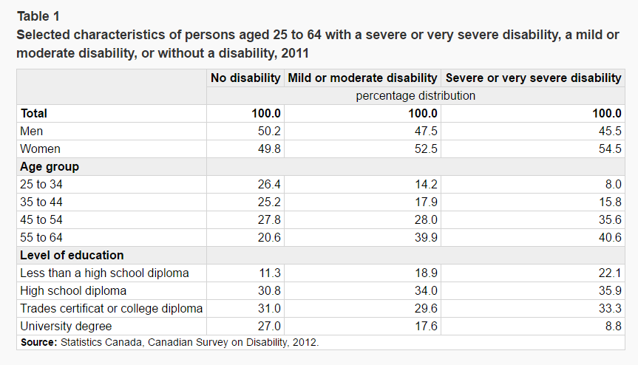

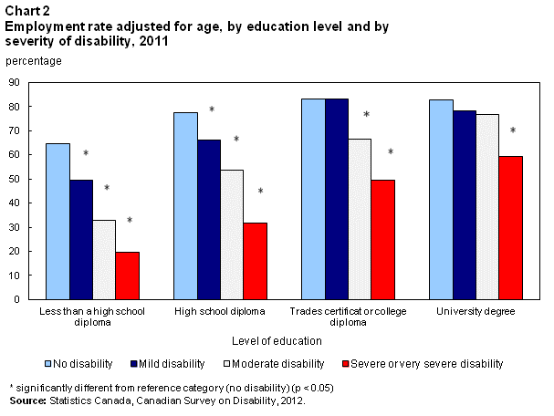

APPENDIX C

LETTER OF SUBMISSION

Jesus Jr. Ancheta

Seneca College of Applied Arts and Technology

Seneca@York Campus

Toronno, Utopia

November 28, 2016

Anna Parker

Director of Student Entrepreneurs

Government of Utopia

Toronno, Utopia

Dear Anna Parker:

**Re: REQUEST FOR PROPOSAL**

Thank for the opportunity to take part on the new program for young entrepreneurs launched by the government of Utopia. As an emerging company in the market, we believe that we have the right vision to develop web applications that help people with disabilities acquire a quality education without difficulties to help them improve their lives.

Our enclosed proposal has been prepared by extensive research on the needs of people with disabilities and existing competitors as required by the RFP. Moreover, we gathered enough information on existing technologies and chose the best one to apply in this initiative.

ByteNet Software Solutions Incorporated considered that this is the best solution to answer the needs of education for people with disabilities and we hope that you will take into consideration also. We are open to discuss this proposal at your convenience and you may contact me on my email at [jjancheta@myseneca.ca](mailto:jjancheta@myseneca.ca) or thru phone at (647) 778 7210.

Sincerely yours,

Jesus Jr Ancheta

Jesus Jr ANCHETA